**Lab 4.4**

***Remove the break statements from each of the cases. What is the effect on the execution of the program?***

In removing the breaks, the higher the case is placed in the program, the more outputs it will display if the input matches such case (because it will display all the outputs of all the rest of the cases). For example, getting an A in this program displays the output of getting a B, C, D, F and even the input validation. The lower the case is placed in the program, the less outputs it will display (because it cannot display the outputs of the above cases). For instance, if the input were an F, then the program displays F's output, and that of the input validation alone (the rest which are above are ignored). Here is the output of an A:

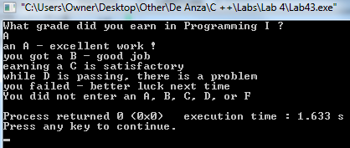

***Add an additional switch statement that allows for a Passing option for a grade of D or better. Use the sample run given below to model your output. Sample Run: What grade did you earn in Programming I ? A YOU PASSED! an A - excellent work!***

I added the statement for anything from D and above. The following output is displayed (if the bricks are not being removed):

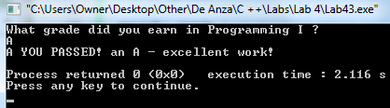

***Rewrite the program LastFirst_lab44.cpp using if and else if statements rather than a switch statement. Did you use a trailing else in your new version? If so, what did it correspond to in the original program with the switch statement?***

I rewrote the program using if and else if statements.

Yes, the trailing else in my new version corresponds to the default in the switch version:

default: ***cout << "You did not enter an A, B, C, D, or F" << endl;***

